**VISVESVARAYA TECHNOLOGICAL UNIVERSITY**

**JNANA SANGAMA, BELAGAVI – 590018**

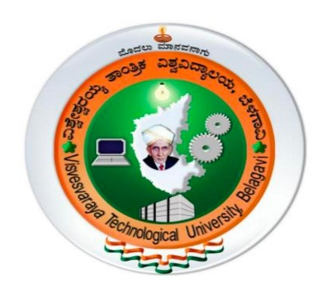

**INTERNSHIP REPORT (21INT68)**

**on**

**“PYTHON DEVELOPMENT AND BACKEND DEVELOPMENT” Carried out**

Submitted in partial fulfilment for the award of degree of

**Bachelor of Engineering**

**in**

**Electronics and Communication Engineering**

**For the Academic Year 2023-2024**

Submitted by

**DHANALAXMI D (USN: 1HK22EC400)**

VI SEMESTER

UNDER THE GUIDANCE OF

**External guide Internal Guide**

Santosh Parmar Prof. Induja P

Company name: ZF India Solutions Dept of ECE



**HKBK COLLEGE OF ENGINEERING**

**22/1, NAGAWARA, BENGALURU – 560 045**

**HKBK COLLEGE OF ENGINEERING, BENGALURU-560045**

**DEPARTMENT OF ELECTRONICS and COMMUNICATION ENGINEERING**



**COLLEGE CERTIFICATE**

This is to certify that this internship report titled **“Python development and Backend development”** carried out by DHANAALAXMI D bearing USN 1HK22EC400, a bonafide student ofHKBK College of Engineering, in partial fulfilment for the award of Bachelor of Electronics and Communication Engineering of the Visvesvaraya Technological University, Belagavi during the year 2023-2024 is a genuine curriculum program.

Intern has successfully completed his/her training from 27/10/2023 to 23/11/2023. During the

internship, the intern maintained a professional demeanor and has gained several skills and

competencies.

It is certified that all the corrections/suggestions indicated before the assessment and evaluation have been incorporation by the interns in this internship report. The internship report has been approved as it satisfied the academic requirements prescribed by the relevant VTU notifications and institute for the award of B.E degree.

**_____________ ____________ __________ ________________**

**Prof**. **Induja P Dr. Abdul Azeez Dr. Latha R Dr. Mohammed Riyaz Ahmed**

Internal Guide Internship Coordinator H.O.D Principal

HKBKCE HKBKCE HKBKCE HKBKCE

**COMPANY CERTIFICATE**

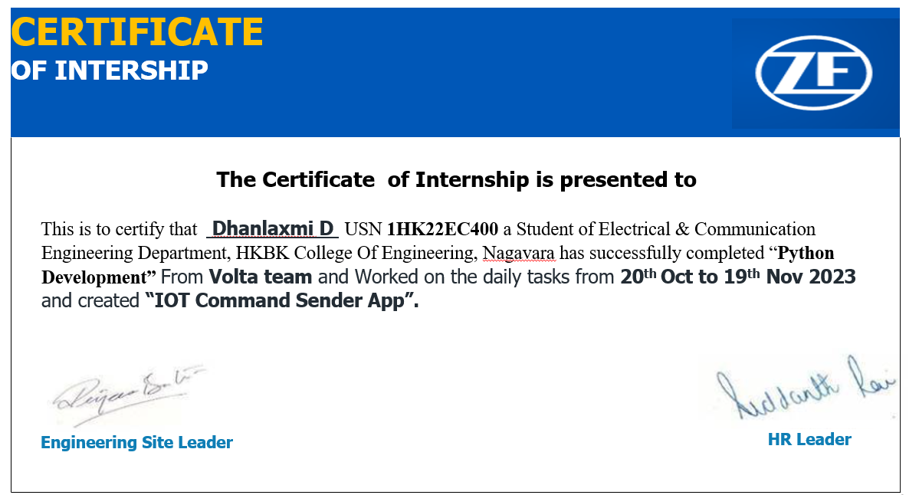

**HKBK COLLEGE OF ENGINEERING, BENGALURU-560045**

DEPARTMENT OF ELECTRONICS and COMMUNICATION ENGINEERING



**DECLARATION**

I, **DHANALAXMI D** bearing **1HK22EC404** student of VI semester, B.E degree in Electronics and Communication Engineering declare that this Intra Institutional Internship Program (Internship-2) titled “Introduction to Industrial Automation” is original work carried out by me, the undersigned in the college campus at after endorsement and authorization from competent authorities of HKBK College of Engineering, in partial fulfilment of the curriculum requirements prescribed by Visvesvaraya Technological University, Belagavi in the 2021 B.E Degree Choice Based Credit System Scheme. The content in this report is not submitted to any other university partially or wholly for the award of any other degree.

DHANLAXMI D

**1HK22EC400**

VI Sem, B.E ECE

**Date**: 06/08/2024

**Place**: Bengaluru

**ACKNOWLEDGMENT**

The euphoria that accompanies the acquisition of vocational skills by professing internship program and compiling internship report would be complete only by acknowledging the governing bodies and the personnel, who by their supervision steered and crowned out my effort with success. I would like to express my profound gratitude to our Director, **Mr. C.M. Faiz Mohammed** for setting up a vibrant learning atmosphere and quality procedures that fetched the institution NAAC and NBA accreditation and transcend the institution to the forefront of literary renaissance. I would like to express my heartfelt thanks to our **Principal Dr. Mohammed Riyaz Ahmed**, HKBK College of Engineering, for his enduring encouragement and support to the students in academic and co-curricular pursuits. I would like to express my genuine thanks to our Head of Department**, Dr. Latha R** for facilitating the internship program and her support in our academic and co-curricular activities. I would like to extend my profound thanks and admiration to my Internal Guide **Prof. Induja P. Assistant Professor**, Department of Electronics and Communication Engineering for his/her constant guidance and critical comments through the course of the Internship. I would like to extend my heartfelt appreciation to **Dr. Abdul Azeez**. Associate Professor and internship coordinator, for his invaluable support and guidance throughout my internship experience. Dr. Abdul Azeez played a pivotal role in providing me with opportunities to learn and grow professionally. Their insightful feedback, encouragement, and mentorship have significantly contributed to my development during this internship.

**NAME: DHANALAXMI D**

**USN: 1HK22EC400**

**ABSTRACT**

This project leverages Python's simplicity and extensive libraries to rapidly develop a data analysis tool, utilizing libraries like NumPy, pandas, and scikit-learn for efficient data processing, visualization, and machine learning capabilities. It provides insights into complex data sets, facilitating informed decision-making. Python's versatility and scalability enable easy extension to accommodate evolving requirements. Additionally, the project focuses on designing and implementing a scalable and secure backend infrastructure for web applications using frameworks like Django or Flask. It ensures efficient server-side logic, database management, and API integration while emphasizing security and performance optimization. Employing best practices for data storage, authentication, and error handling, the resulting backend architecture supports high traffic volumes and ensures a seamless user experience, providing a solid foundation for web application development.